Neil Mackenzie
Mentorship Excellence Award
Background and Guidelines
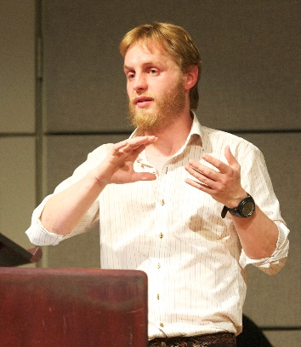
Each individual’s contribution is important to the growth and success of CBR. There are those among us who go a step farther, over and above what is expected of them. Dr. Neil Mackenzie was a postdoctoral fellow in Dr. Brömme’s lab. He was a dedicated and caring mentor whose enthusiasm and positive attitude exemplified his ability to motivate and support his colleagues. In Neil’s memory, each year CBR recognizes an individual who has demonstrated outstanding commitment to mentorship and the development of others.
Neil Mackenzie
ELIGIBILITY: All current CBR staff members, trainees, PDFs and RAs (not PIs) are eligible to be nominated.
NOMINATION PROCEDURE: CBR members may nominate a candidate by completing this form and sending it to stefanie.mak@ubc.ca by July 18th, 2021 at 11:59 pm PT. Nominations will be evaluated by the CBR Awards Committee. Award recipients will be announced at a special ceremony on Research Day, where they will receive a recognition award.
DONATION FUND: All funds raised in recognition of Neil’s service to the CBR community will support the CBR mentorship efforts and the summer studentship program.
QUESTIONS? Contact Dr. Stefanie Mak at stefanie.mak@ubc.ca.

Selection Criteria
This individual demonstrates significant commitment to mentorship and the development of others.
- Advocates and creates opportunities for others to develop and demonstrate their competencies;
- Is approachable and responds in a cooperative and courteous manner;
- Responds to individuals’ suggestions and concerns in a serious, sensitive and respectful way;
- Shares information and knowledge and leads by example;
- Provides steady, constructive and timely feedback.

e.g., Layla empowers those more junior than her to undertake tasks that are challenging. She oversees the work without micromanaging, and offers respectful feedback and support. She seeks ways to build the team’s skills based on an individual’s interests and is open to ideas on how tasks can be done more efficiently and effectively.

Neil Mackenzie Mentorship Excellence Award Nomination Form
Your Name: |  | Your Lab/Group:
Nominee’s Name: |  |  | Nominee’s Lab:
Please describe why your nominee is an outstanding mentor. It is best to use stories or examples (use the space below – 500 words maximum).

Please email the completed nomination form to Dr. Stefanie Mak (stefanie.mak@ubc.ca) by July 18, 2021 at 11:59 pm PT.
You can also download this form online: https://cbr.ubc.ca/research-and-training/grad-pdf-training/

