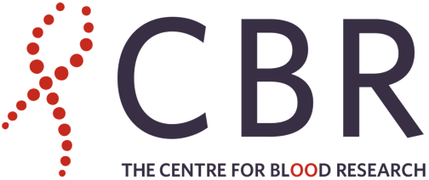

**Earl W. Davie Symposium 2023**

**TRAVEL AWARDS**

The goal of the Earl W. Davie Symposium is to disseminate advances in the field of hemostasis-thrombosis, as applied to innate immunity, infectious diseases, inflammation and cancer.

This year’s symposium will take place on **Thursday, November 16, 2023**, at UBC Robson Square in Vancouver, Canada. **Registration is free!**

The CBR believes in supporting trainees to share their research and expand their scientific horizons through travel, and to disseminate knowledge between institutions. With funding from the Sheldon Naiman and Linda Vickars Endowment Fund, the CBR will support travel and accommodation expenses for trainees to attend and present at the symposium. Expenses will be reimbursed to a maximum of **CAD $1,500** after the meeting, upon submission of original receipts.

**ELIGIBILITY:** Trainees who are external to the CBR are eligible to apply. This includes undergraduate, MSc and PhD students, Postdoctoral Fellows and Research Associates, MDs-in-training and para-medical personnel (e.g., thrombosis-haemostasis nurses, nurse practitioners).

**APPLICATION PROCEDURE:**

**1.** [**Register**](https://ubc.ca1.qualtrics.com/jfe/form/SV_0JxHWTazykpg6Ue)

**2.** [**Submit an abstract**](https://ubc.ca1.qualtrics.com/jfe/form/SV_0oBI3nR5NRXiQC2)(poster or oral presentation) **REQUIRED!**

**3.** Send a letter from the applicant’s PI or department head that confirms the applicant’s training/professional status to [Parvin Bolourani](mailto:parvin@mail.ubc.ca)

**DEADLINE:** Friday, **October 6, 2023**

Successful applicants will be notified before October 20

**QUESTIONS?**Contact [Parvin Bolourani](mailto:parvin@mail.ubc.ca) or [Ed Conway](mailto:ed.conway@ubc.ca)